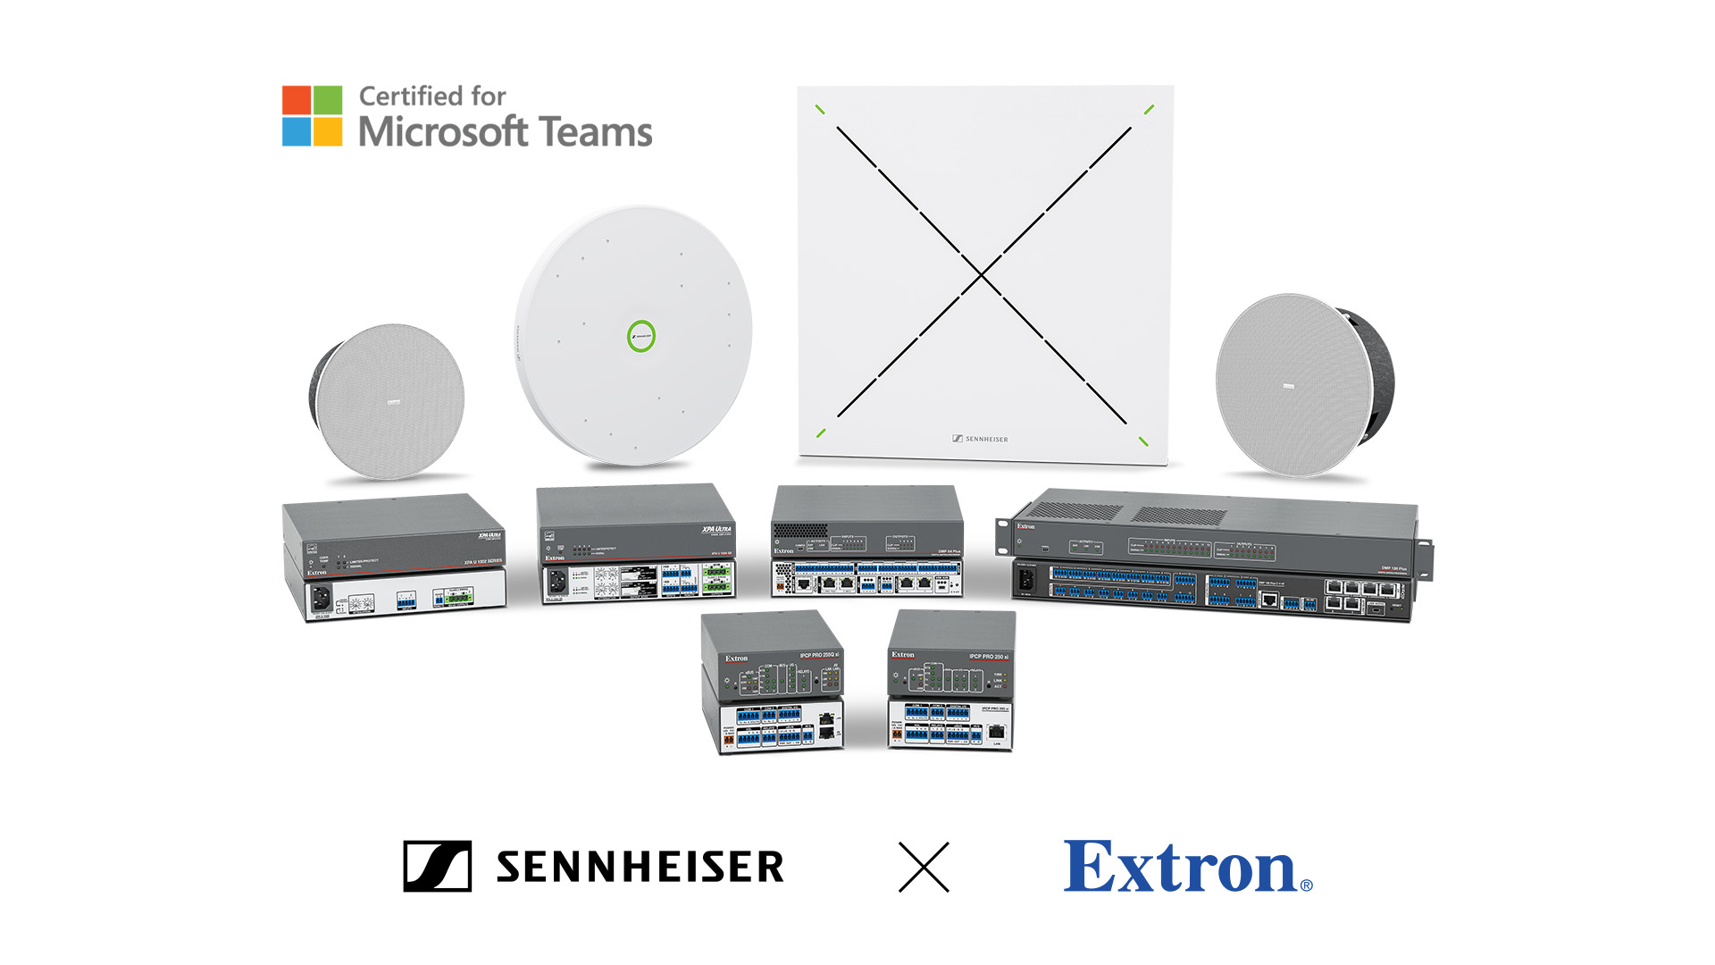

Extron and Sennheiser Introduce New Secure, AI-Ready Enterprise Solutions Certified for Microsoft Teams

Sydney, Australia - February 10, 2025 - Extron and Sennheiser are pleased to announce that their popular Design Solutions devices, Certified for Microsoft Teams now include select control processors from Extron’s IPCP Pro xi Series and the new TeamConnect Ceiling Medium - TCC M - ceiling microphone from Sennheiser. Extron has worked with Sennheiser and Microsoft to support these new meeting space solutions that deliver an unmatched user experience, all while focusing on the security that is built right into the products.

As AI-powered tools like Microsoft 365 Copilot transform workplace collaboration, clear and reliable audio has become more critical than ever. These tools depend on precise voice capture to effectively transcribe, analyse, and act on meeting content. The TCC M microphone from Sennheiser ensures every participant is heard clearly, regardless of their position in the room, enabling smarter, more productive meetings.

“Our ongoing collaboration with Sennheiser and Microsoft continues to deliver new, secure conferencing solutions that are Certified for Microsoft Teams,” says Casey Hall, Chief Marketing Officer for Extron. “We are confident that integrators will appreciate the exceptional quality and flexibility of these solutions.”
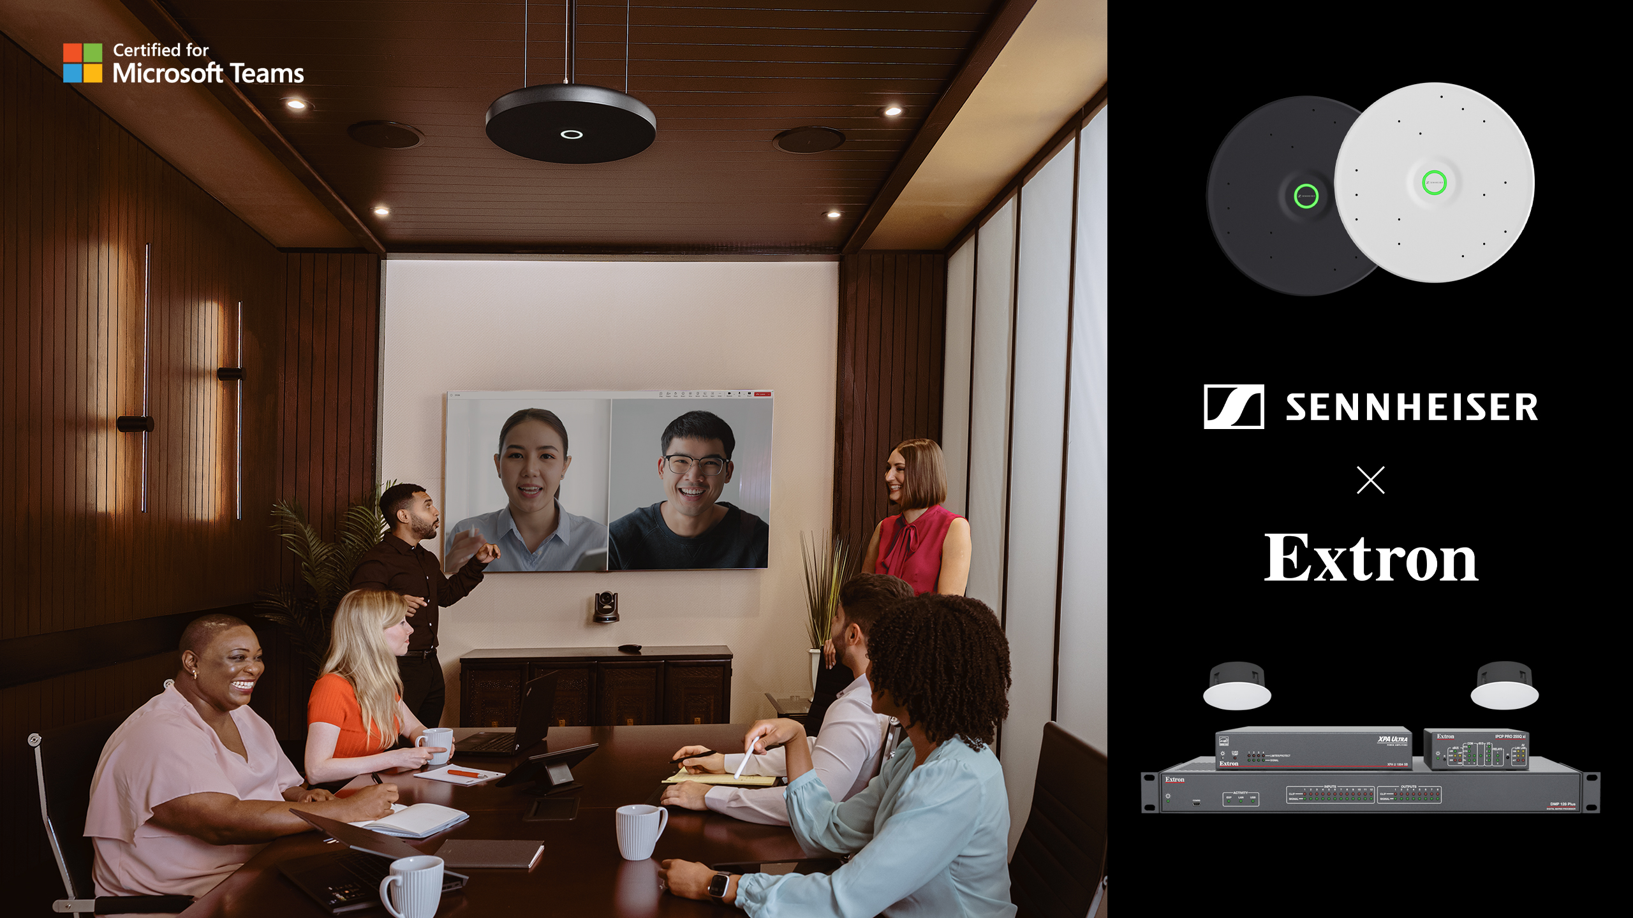

“We are thrilled to collaborate with Extron to expand the range of solutions Certified for Microsoft Teams available to integrators," said Charlie Jones, Sennheiser's Global Partner Relations Manager. “With the rise of AI-driven tools like Microsoft 365 Copilot, clear, high-quality audio has become more important than ever. Our TeamConnect Ceiling Medium microphone ensures every word is captured with precision from anywhere in the room. Paired with Extron’s exceptional control systems, integrators can deliver smarter, more efficient meeting spaces for today’s workplace.”

“A lot of high value content is created in meeting rooms,” said Albert Kooiman, Senior Director, Microsoft Teams Partner Engineering and Certification and Customer Experience at Microsoft Corp. “By providing solutions that are Certified for Microsoft Teams, Extron and Sennheiser can help deliver on critical Teams AI features like speaker attributed meeting transcriptions and meeting recaps, that benefit all users.”

Extron Products Certified for Microsoft Teams
- DMP 64 Plus and DMP 128 Plus Series Digital Audio Matrix Processors
- XPA U 1002 and XPA U 1004 SB Power Amplifiers
- SF 3CT LP and SF 26CT Series Ceiling Speakers
- IPCP Pro xi 250 and IPCP Pro 255Q xi Quad Core Control Processor

Sennheiser Products Certified for Microsoft Teams
- TeamConnect Ceiling Medium Ceiling Microphone array
- TeamConnect Ceiling 2 Ceiling Microphone array

Microsoft Teams Rooms Solution Capabilities
- Connects the room with a Microsoft Teams meeting
- Exceptional intelligibility with Extron AEC
- Enterprise level routing flexibility and device compatibility with Dante AoIP
- Clear audio playback
- Secure control system integration, including the industry standard 802.1X
- Flexible installation options
- Paintable ceiling elements to blend in with any décor

To find the complete certified designs, featured solutions, and detailed information on the individual products they include, head to the Extron website. With Extron control for Teams Rooms, a single user interface is all you need to securely control every conferencing, audiovisual, and room function. Together, Extron and Sennheiser deliver complete AV and conferencing control for your enterprise, ensuring your spaces are equipped for the future of collaboration.

For more information on these Design Solutions devices that are Certified for Microsoft Teams, click here.

About the Sennheiser brand
We live and breathe audio. We are driven by the passion to create audio solutions that make a difference. Building the future of audio and bringing remarkable sound experiences to our customers – this is what the Sennheiser brand has represented for more than 75 years. While professional audio solutions such as microphones, meeting solutions, streaming technologies and monitoring systems are part of the business of Sennheiser electronic GmbH & Co. KG, the business with consumer devices such as headphones, soundbars and speech-enhanced hearables is operated by Sonova Holding AG under the license of Sennheiser.

www.sennheiser.com
www.sennheiser-hearing.com

Extron – The AV Technology Leader
Every day, millions of people around the world are having their experiences enhanced by Extron audiovisual signal processing, distribution, and control solutions. We design advanced technologies to create better looking images, higher quality sound, systems that are easier to control and work more reliably. Our powerful asset management tools are helping technology professionals efficiently manage large numbers of audiovisual systems deployed throughout their enterprises and institutions. Extron AV technology solutions serve the diverse needs of organizations around the world and are deployed in a wide variety of corporate, educational, government, healthcare, retail, and entertainment applications.

To learn more about Extron, click here.

Extron® is a registered trademark of Extron.

Communications Manager – Americas & ANZ
Daniella Kohan
+1 860 598 7420
daniella.kohan@sennheiser.com

